Date: 22.01.2026

BCOM AIDED ATKT EXAM NOTICE
College ATKT – NEP (Batch 2024-2025)

Students who will appear for ATKT Examination FYBCom (Sem I) February 2026 (NEP students) are requested to fill up the ATKT form after paying online fees.

Fees Payment Dates – 23rd January 2026 to 29th January 2026

Account Details are as follow: -
Bank Name: Indian Bank
Account Name: Vivek College of Commerce
Account No: 422695775
IFSC Code: IDIB000S128
Branch: Vivek Vidyalaya
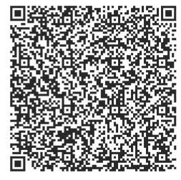
Scanner for ATKT exam fees payment

Examination Fees Payment Details:
- 1 subject: Rs. 500/-
- 2 subjects: Rs. 1000/-
- 3 & above subjects: Rs. 1500/-

Payment should be done before filling the Google form given below and please mention the Transaction ID in the Google form otherwise your form will not be accepted.

Link:
https://forms.gle/NssDP4Y34WA8VYA59

Note:
- ATKT forms will not be entertained thereafter.
- If there is an increase in fees for exam from University of Mumbai, the difference in the amount will be collected on result distribution day.
- Please pay the exact fees for the ATKT examination as given above subject wise. No extra fees paid by the student will be refunded by the college.
- Please mention your name and class in the remark while paying your fees.

Principal

